ON CONVOLUTION OF A SUBCLASS OF HARMONIC UNIVALENT FUNCTIONS

Makinde D.O., PhD
Afolabi A.O., MR
Department of Mathematics, Obafemi Awolowo University, Ile-Ife, Nigeria

Abstract:
In [4], Frasin studied the harmonic univalent functions and defined the class consisting of the functions where and are the analytic and co-analytic part of the function respectively. In this paper, we introduce the class of analytic functions and consider the convolution of the function of the form and We investigated the coefficient inequlities and distortion theorems for the function .

Keywords: Harmonic, Univalent, Convolution, Coefficient in equalities, Growth and distortion.

- Introduction
A continuous complex valued function defined in a simply connected complex Domain, D, is said to be harmonic in D if both and are real harmonic in D. In any simply connected domain we can write , where h and g are analytic in D. We call h the analytic part and g the co-analytic part of f. A necessary and sufficient condition for to be locally univalent and sense preserving in D is that in D.
Let denote the family of functions that are harmonic univalent and sense preserving in the unit disk for which. Then for we may express the analytic functions h and g as;
The harmonic function for g ≡ 0 reduces to an analytic function .
Since 1984, there have been several papers related on and its subclasses.
In 1994, Jahangiri [5] defined the class consisting of functions such that and are of the form
which satisfy the condition
Jahangiri [1] also proved that if is given by (1) and if
Then is harmonic, univalent and starlike of order in U. This condition is proved to be also necessary if .
In 2005, B. A. Frasin [4] defined the class consisting of functions such that h and g are of the forms (2) and satisfy the condition.
B. A. Frasin [4] proved that if be such that and are given by (2) and if , then
Where
In this paper, we express the analytic functions and as:
We now present our main results.
2. Main Results
Suppose we have the functions, and are in such that ,, , and are of the form
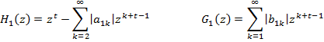
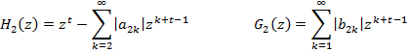
We define the convolution of and as
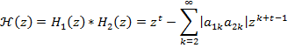
and the convolution of and as
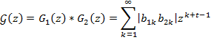
So that the convolution
is a member of harmonic univalent function
which satisfies the condition
We shall now proof the coefficient inequalities for the convolution function and the growth and distortion theorem of the analytic part

COEFFICIENT INEQUALITIES
THEOREM 1
Let the function be so that and are given by .
If , then
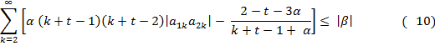

PROOF:
From
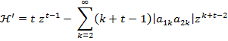
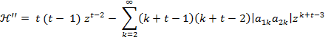
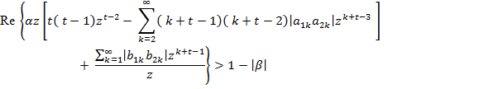
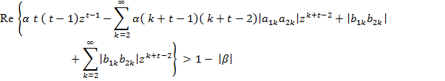
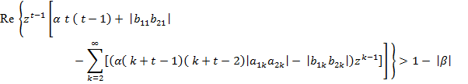
Choose z to be real and z we have;
By hypothesis, we have;
Now, since , from we have:
This implies;
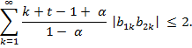
Thus,
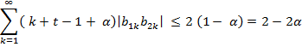
This implies;
Substituting into we have
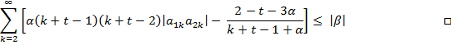

COROLLARY 1
Let the function be so that and are given by .
If , then
THEOREM 2
Let the function be so that and are given by . If , then where; 0 < t 1, .
PROOF:
Let , then by theorem 4.6, we have
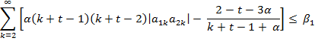
By hypothesis, we then have;
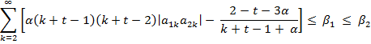
This implies,
Hence;
□

GROWTH AND DISTORTION THEOREMS
THEOREM 3
Let the function be so that and are given by .
If , then for , we have:
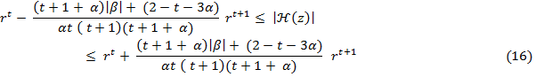
and

PROOF:
Let , then from (12) we have:
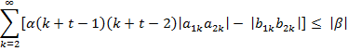
Since , from (34) we obtain
So that (18) reduces;
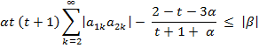
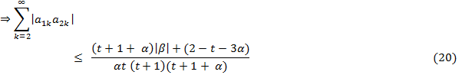
Recall that;
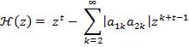
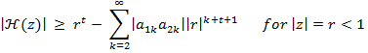
From (19)
Similarly,

Combining (21) and (22) we have the result (16) and
Furthermore; we have from (12), that
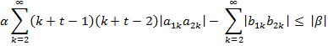
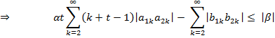
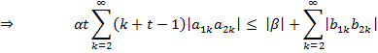
Since , from (13) we obtained
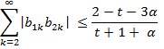
So that we have;
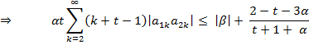
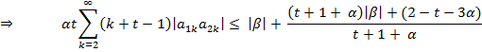
But
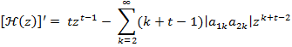
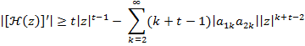
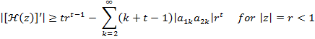
From (23), we have;
From (24)
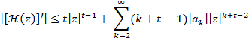
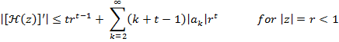
Combining (25) and (26) we have the result (17)
Hence, the inequality in (37) and (38) are attained for the functions and given by:
and

References:
K. Al-Shaqsi, M. Daru and A.F Olubunmi, Hindawi Publishing Corporation Abstract and Applied Analysis, Article ID 821531, pages 1-12, 2010.
J. Clunie and T. Sheil-Small, Harmonic Univalent Function, Ann. Acad. Sc. Fenn. Math 9, pages 3-25, 1984.
K.K. Dixit, A.L. Pathak, S.Porwal, and R. Agarwal, International Journal of Pure and Applied Mathematics, Volume 69, No. 3, pages 255-264, 2011.
B.A Frasin, Korean Math. Soc. 42 No. 3, pages 563-569, 2005.
J. M Jahangiri, Harmonic Function Starlike in the Unit disk, J. Math Anal Appl. 235, pages 470-477, 1999.
D. O. Makinde and A. O. Afolabi, On a Subclass of Harmonic Univalent Functions, Transitional Journal of Science and Technology. Volume 2 No 2 pages 1 – 11, 2012
H. Silverman, Harmonic Univalent Function with Negative Coefficients, J. Math Anal. Appl. 220, pages 233-289, 1998.

